2024 Bitterroot  Next Level Hunter Camp  Elevating hunters’ skills, ethics, and marksmanship thru hands-on training  Apply today at RCFWA.org click on Events or Ravalli  County Fish and Wildlife Association Facebook site  Class tuition $150 and space is limited. Selection based on experience and essay response. Scholarships available.  Two days of engaging, practical, and highly instructive training. Graduates become more effective in the field and gain access to selected private lands for the 2024 big game season.  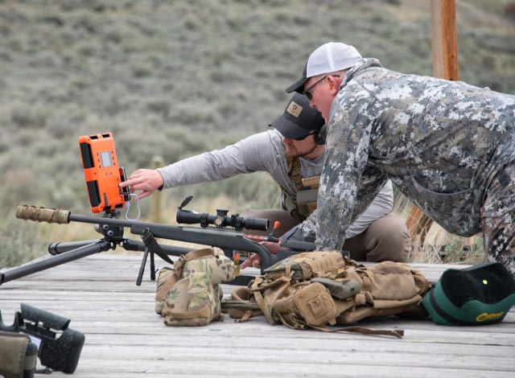  Sponsored by Ravalli County Fish and Wildlife Association, with support from Montana Outdoor legacy Foundation and Rapp Family Foundation, onX, Scheels and FHFgear. | When: May 3 & 4, 2024, 9am to 5pm  Where: MPG Ranch, near Florence, MT  How to apply: send name, age, phone number and 100-word essay to RCFWA.org click on Events.  Essay Topic: Why are the class topics for Day 1 and Day 2 important to me as a hunter?  Day 1: Range Day, effective shooting fundamentals with top-level firearms instructors at MPG Ranch rifle range  Day 2: Hunter ethics panel discussion with ranchers, farmers. Wildlife Law discussion with retired game wardens. Wildlife Management with professional wildlife biologist  Maximum Class size is 10 students  Qualifications: Hunters with at least 5 years hunting experience  To apply or Questions: log onto  https://rcfwa.org  Go to contact us to send in your information.

